**M2 INTERNSHIP PROPOSAL (2023-2024)**

**Internship title:**

Long non-coding RNAs in the mitosis to meiosis switch in fission yeast

**Internship description:**

The transition from mitosis to meiosis is a key differentiation process essential for the transmission of the genetic information to the next generation. The profound modifications in gene expression profiles imply the existence of molecular mechanisms to establish and maintain cell type-specific programs. In the fission yeast *Schizosaccharomyces pombe*, the YTH family RNA-binding protein Mmi1 selectively targets meiotic transcripts for degradation by the nuclear exosome during mitosis, thereby preventing their untimely expression (**Fig. 1a**). Upon entry into meiosis, Mmi1 is sequestered within a complex comprising the RNA-binding protein Mei2 and the long non-coding RNA meiRNA, allowing expression of the meiotic program (**Fig. 1b**).

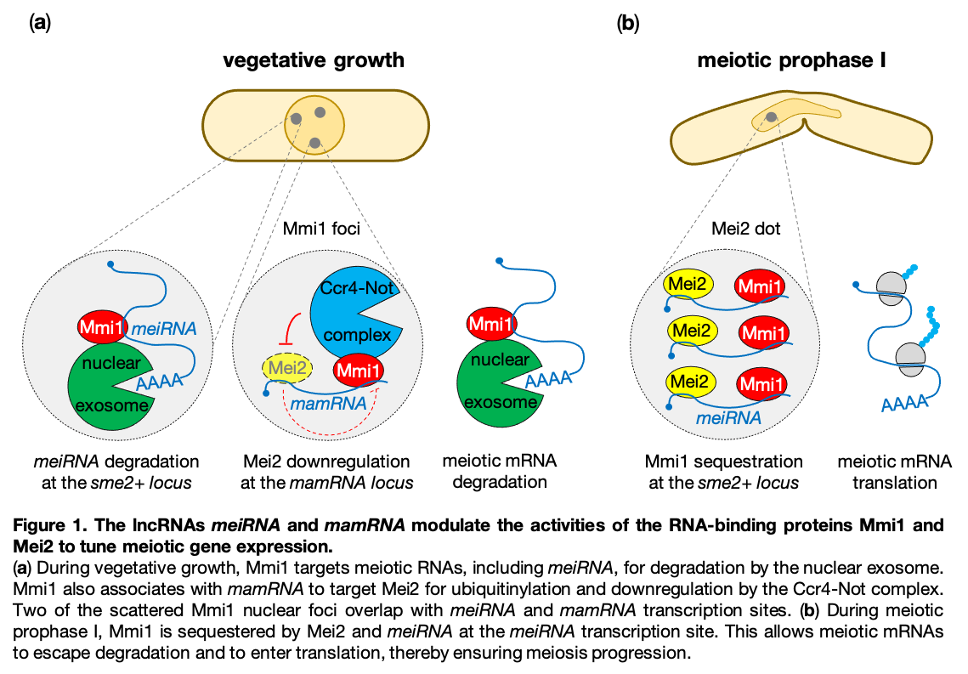 Recent work in the lab showed that during mitotic growth, Mmi1 associates with another lncRNA, called mamRNA (for Mmi1 and Mei2-associated RNA), to target its own inhibitor Mei2 for ubiquitinylation and downregulation by the Ccr4-Not complex (**Fig. 1a**). This regulatory circuit is essential to maintain low levels of Mei2 in mitosis and hence to preserve Mmi1 function in meiotic mRNA degradation. Remarkably, mamRNA, which localizes to a nuclear body enriched in Mmi1 in mitotic cells, is also necessary for Mmi1 inhibition by increased Mei2 levels. These results support the existence of a lncRNA-dependent and spatially-confined mutual control of Mmi1 and Mei2.

The existence of two ribonucleoprotein complexes, Mmi1-Mei2-mamRNA et Mmi1-Mei2-meiRNA, raises novel questions about the regulation of sexual differentiation in *S. pombe*. Notably, what is the functional interplay between these complexes during the mitosis to meiosis switch? How are they remodeled along the developmental transition? The objectives of the internship will consist in:

* Studying the dynamics of Mmi1, Mei2, mamRNA et meiRNA expression during the mitosis-meiosis transition in wild type cells and mutants of these factors. The obtained profiles will provide clues about the order of the regulatory events involved.
* Studying the binding profiles of Mmi1 and Mei2 to their RNA targets during sexual differentiation. This will allow determining not only the dynamics of Mmi1-Mei2-mamRNA and Mmi1-Mei2-meiRNA assembly/disassembly but also the timing of Mmi1 sequestration by Mei2-meiRNA, which prevents recognition and degradation of meiotic mRNAs.

The candidate will use classical techniques in yeast genetics, molecular biology and biochemistry (Western Blot, Northern Blot, coIP, RT-qPCR, RIP-qPCR,…). High-throughput sequencing (RNA-seq, RIP-seq) and proteomic (mass spectrometry) approaches will also be envisioned.

**Key words**

RNA-binding proteins, long non-coding RNAs, meiotic gene expression, sexual differentiation, fission yeast

**Model organism used:**

fission yeast *Schizosaccharomyces pombe*

**Bibliography:**

1. V. Andric, M. Rougemaille, Long non-coding RNAs in the control of gametogenesis: lessons from fission yeast. Noncoding RNA.7(2):24.

2. V. Andric, A. Nevers, D. Hazra, S. Auxilien, A. Menant, M. Graille, B. Palancade, M. Rougemaille M, A scaffold lncRNA shapes the mitosis to meiosis switch. Nat. Commun. 12(1), 770.

3. F. Simonetti, T. Candelli, S. Leon, D. Libri, M. Rougemaille, Ubiquitination-dependent control of sexual differentiation in fission yeast. Elife 6, e28046 (2017).

4. Y. Harigaya, H. Tanaka, S. Yamanaka, K. Tanaka, Y. Watanabe, C. Tsutsumi, Y. Chikashige, Y. Hiraoka, A. Yamashita, M. Yamamoto, Selective elimination of messenger RNA prevents an incidence of untimely meiosis. Nature 442, 45-50 (2006).

**Perspectives**

The internship can be pursued by a PhD thesis, should funding be obtained by the candidate.

**Team members**

Institute for Integrative Biology of the Cell (UMR9198)

CEA, CNRS, Univ. Paris-Saclay

Department of Genome Biology

Team « RNA-binding proteins in gene expression and cell differentiation »

Avenue de la Terrasse – Bât 26

91190 Gif-sur-Yvette

Mathieu Rougemaille, DR2 CNRS, HDR, group leader (supervisor of the internship)

Alexandra Menant, Researcher, CNRS

Stéphane Pelletier, IE CNRS

Drice Challal, postdoctoral fellow

Estelle Leroy, 2nd year PhD student

<https://www.i2bc.paris-saclay.fr/equipe-rna-binding-proteins-in-gene-expression-and-cell-differentiation/>

e-mail: [mathieu.rougemaille@i2bc.paris-saclay.fr](mailto:mathieu.rougemaille@i2bc.paris-saclay.fr)

phone: 01 69 82 31 39