

**Laboratory and host team**:

Conformation and Segregation of the Bacterial Chromosome

Head of the host team: Frédéric Boccard

**Internship supervisor:**

Virginia S. Lioy: [virginia.lioy@i2bc.paris-saclay.fr](mailto:virginia.lioy@i2bc.paris-saclay.fr)

Stéphanie Bury-Moné: [stephanie.bury-mone@i2bc.paris-saclay.fr](mailto:stephanie.bury-mone@i2bc.paris-saclay.fr)

**Characterization of chromosome organization in non-replicating *Pseudomonas aeruginosa* cells.**

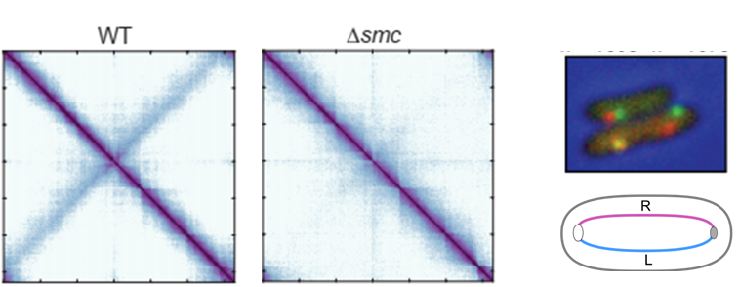

*P. aeruginosa* is an ubiquitous opportunistic pathogen, that causes serious infections in immunocompromised patients, and it is the leading cause of morbidity in cystic fibrosis patients. These infections are particularly challenging because of *P. aeruginosa* broad intrinsic antimicrobial resistance. During the infection cycle, *P. aeruginosa* modulate its DNA replication state: free-living bacteria are dividing cells in which DNA is replicated until they attached to a surface and the biofilm state is adopted During acute infection, *P. aeruginosa* can also invade and survive inside epithelial cells. Within the infection process, bacterial cells present a degree of DNA replication, from non-replicating cells to actively replicating ones. Despite this, neither the replication process nor the impact of this process on the overall genome organization are extensively studied in *P. aeruginosa* during infection. We have developed tools to dissect the contribution of DNA replication on *Pseudomonas* chromosome dynamics. Here, the master student will characterize *P. aeruginosa* genome organization in the absence of ongoing replication by applying innovative approaches: Fluorescence microscopy, transcriptomics and genomic techniques.

**During the internship:**

The M2 will learn fluorescence microscopy, bacterial genetics, transcriptomic (mainly bioinformatics analyses), molecular microbiology and will work in a BSL2 environment.

**References:**

1. Lioy, V.S., Junier, I., and Boccard, F. (2021). Multiscale Dynamic Structuring of Bacterial Chromosomes. Annu Rev Microbiol. 10.1146/annurev-micro-033021-113232.

2. Lioy, V.S., Junier, I., Lagage, V., Vallet, I., and Boccard, F. (2020). Distinct Activities of Bacterial Condensins for Chromosome Management in Pseudomonas aeruginosa. Cell Rep *33*, 108344. 10.1016/j.celrep.2020.108344.

3. Vallet-Gely, I., and Boccard, F. (2013). Chromosomal Organization and Segregation in Pseudomonas aeruginosa. PLOS Genetics *9*, e1003492. 10.1371/journal.pgen.1003492.

4. Lagage, V., Boccard, F., and Vallet-Gely, I. (2016). Regional Control of Chromosome Segregation in Pseudomonas aeruginosa. PLOS Genetics *12*, e1006428. 10.1371/journal.pgen.1006428.