**M2 internship description**

Laboratory of Membrane Proteins and Membrane Systems (LPSM)

<https://www.i2bc.paris-saclay.fr/equipe-membrane-proteins-and-membrane-systems-laboratory/>

Contacts: [thibaud.dieudonne@i2bc.paris-saclay.fr](mailto:thibaud.dieudonne@i2bc.paris-saclay.fr) (Thibaud Dieudonné)

[guillaume.lenoir@i2bc.paris-saclay.fr](mailto:guillaume.lenoir@i2bc.paris-saclay.fr) (Guillaume Lenoir)

*Reconstitution of the Ist2-Osh6 complex in nanodiscs for structural investigation by cryo-electron microscopy*

Phosphatidylserine (PS) is a negatively-charged lipid with critical roles in numerous cellular functions, such a regulation of cell signaling, polarity, vesicular trafficking, or in host-pathogen interactions. Although synthesized in the endoplasmic reticulum, PS is highly enriched in the plasma membrane of eukaryotic cells. Such uneven distribution is maintained by lipid transfer proteins (LTPs), which catalyze transport of lipids at membrane contact sites (MCS), where two organelles are closely apposed. Recently, our collaborators have shown that the yeast cytosolic LTP Osh6 achieves the transport of PS against its concentration gradient, between the ER and the PM. Moreover, it has been shown that Osh6 interacts with Ist2, an ER transmembrane protein that tethers the ER with the PM and thereby maintains the architecture of MCS, and that Ist2 is important for Osh6-mediated PS transport to the PM.

Ist2 belongs to the TMEM16 protein family, whose members have been shown to facilitate transport of lipids from one leaflet of membranes to the other, thereby acting as ‘scramblases’. How the interaction between Ist2 and Osh6 contributes to PS homeostasis has not yet been addressed but we hypothesize functional coupling between Ist2-catalyzed transbilayer movement of PS and transport of PS from the ER to the PM by Osh6. A post-doctoral researcher in our lab currently investigates whether purified and reconstituted Ist2 is indeed able to transport lipids, using fluorescence-based assays. To further nail down the role of Ist2 in Osh6-catalyzed PS transport, we wish to determine the three-dimensional structure of Ist2 and Ist2/Osh6 complex using cryo-electron microscopy (cryo-EM).

The aim of this M2 internship is to reconstitute purified Ist2 in nanodiscs, which are nanometer-sized assemblies of lipids and scaffold proteins that mimic a near-native membrane environment, in order to obtain homogenous particles in size and shape suitable for high resolution structural studies by cryo-EM. The Master 2 student will be involved in the purification of GFP-tagged Ist2 from yeast membranes using a procedure already established in the laboratory, purification of nanodisc scaffold proteins, and reconstitution of Ist2 in nanodiscs. The quality and homogeneity of the reconstituted sample will be assessed by (fluorescence) size-exclusion chromatography and negative stain electron microscopy. Subsequently, conditions for flash freezing (grid type, protein concentration, blotting time) will be screened to obtain optimal particle distribution and ice thickness. Importantly, conditions for forming a complex between Ist2 and Osh6 will be investigated, in order to get insights into the relationships between these two proteins at a molecular level. The student will get new skills with recombinant membrane protein expression, affinity purification, size-exclusion chromatography, reconstitution in membrane mimics, and initial training in cryo-EM techniques, benefiting for the latter of the cryo-EM facility of the Institute for Integrative Biology of the Cell (I2BC).

This internship could be followed by a PhD thesis.

References related to the project (selection of 5):

* Heger T, Stock C, Laursen MJ, Habeck M, Dieudonné T, Nissen P (2023) eGFP as an all-in-one tag for purification of membrane proteins. ***Methods Mol Biol***. 2652:171
* Dieudonné T, Herrera SA, Laursen MJ, Lejeune M, Stock C, Slimani K, Jaxel C, Lyons JA, Montigny C, Pomorski TG, Nissen P, Lenoir G (2022) Autoinhibition and regulation by phosphoinositides of ATP8B1, a human lipid flippase associated with intrahepatic cholestatic disorders. ***eLife***. 11:e75272
* Lenoir G, D’Ambrosio JM, Dieudonné T, Čopič A (2021) Transport pathways that contribute to the cellular distribution of phosphatidylserine. ***Front Cell Dev Biol.*** 9: 737907
* D’Ambrosio JM, Albanèse V, Lipp NF, Fleuriot L, Debayle D, Drin G, Čopič A (2020) Osh6 requires Ist2 for localization to ER-PM contacts and efficient phosphatidylserine transport in budding yeast. ***J Cell Sci.*** 133:243733
* Timcenko M, Lyons JA, Januliene D, Ulstrup JJ, Dieudonné T, Montigny C, Ash MR, Karlsen JL, Boesen T, Kühlbrandt W, Lenoir G, Moeller A, Nissen P (2019) Structure and autoregulation of a P4-ATPase lipid flippase. ***Nature***. 571:366

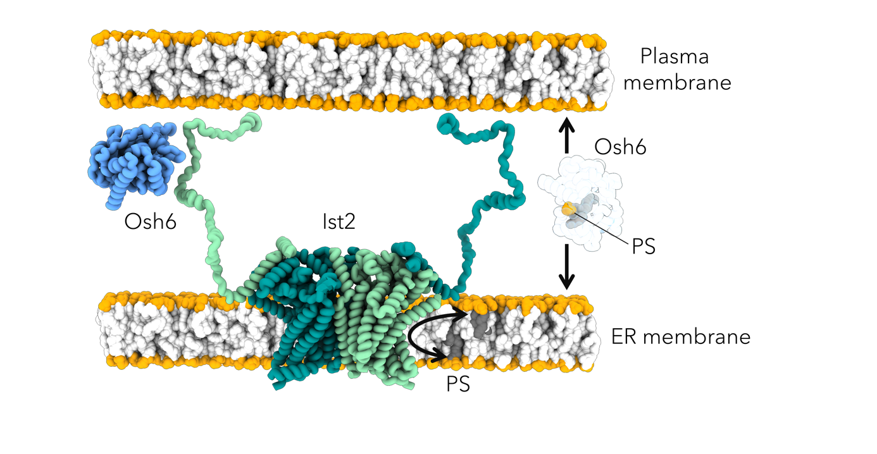

Current working model for phosphatidylserine (PS) transport at ER-PM contact sites mediated by Ist2 and Osh6 proteins. The lipid transport protein Osh6 is recruited to the ER-PM contact sites via its interaction with the C-terminal tail of Ist2, and mediates the transfer of PS from the ER membrane to the PM. In addition to its role in Osh6 recruitment, Ist2 is suspected to mediate the transport of lipids between the two leaflets (flip-flop, black arrow) of the ER membrane, providing Osh6 with its transport substrate.